1

**Web Browser**

BASIC COMPUTER USAGE

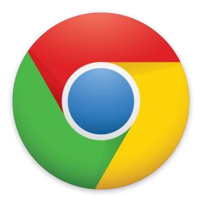

**QUIZ**

**OBJECTIVES FOR TODAY** 

* **Web browser**
* **Google Chrome**
* **Using tabs**
* **Address bar** and **bookmark**
* **Shortcut key**

EXPLORE

10 MIN **Watch** and **answer questions**

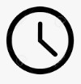

✓List down the **web browsers** presented in this video

✓What is web browser **used for** ?

EXPLORE



10

MIN



EXPLAIN

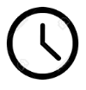

05 MIN **Web Browser**

# A browser is a tool to help you access resources through www on the Internet. There are many

browsers but we focus on **Google Chrome**.

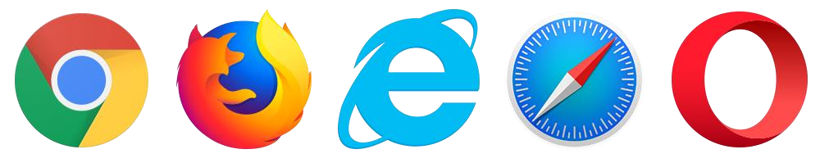

**Mozilla Firefox**

**Internet Explorer**

**Safari**

**Opera**



**Vivaldi**

**Microsoft edge**

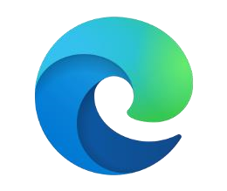

**Google Chrome**

EXPLAIN

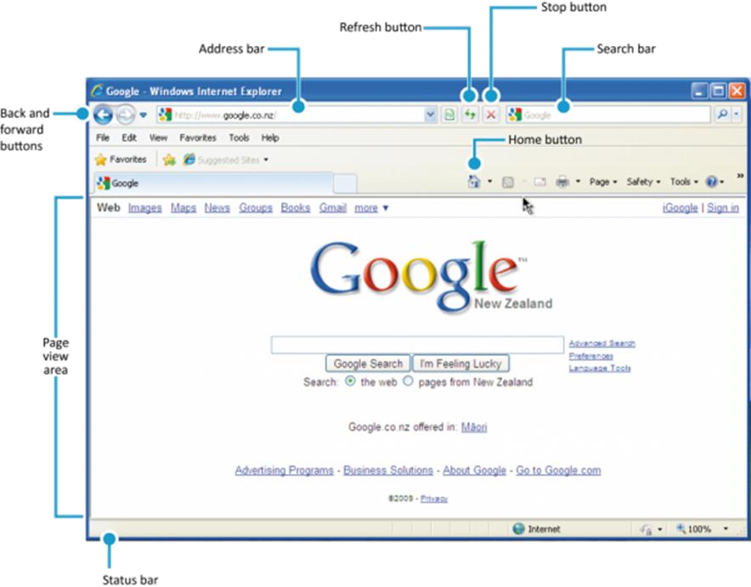

**Web Browser**



05 MIN

DEMO

10 MIN

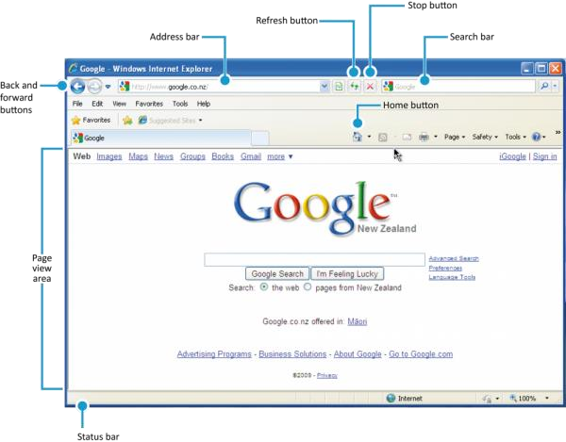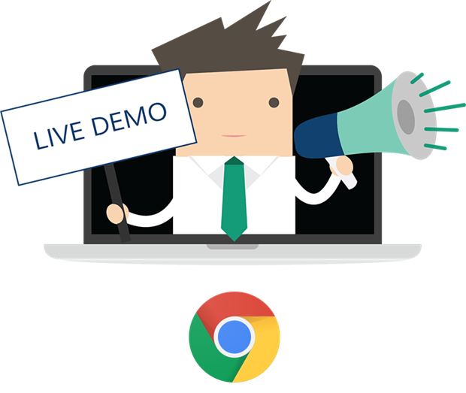

✓Other **web browsers** besides Chrome?

✓Any Volunteer?

EXPLAIN   **Chrome**

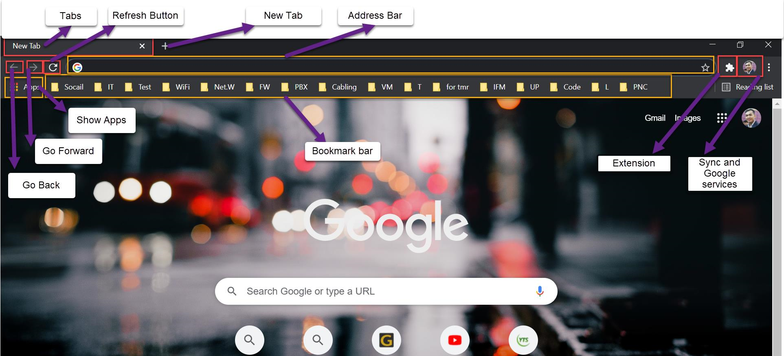

05 MIN

# Tabs

05 MIN

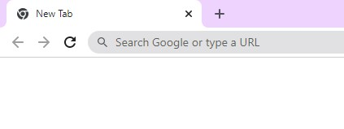

Click this button to close the current tab

Click this button to open the new tab

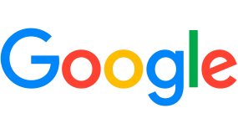

**Shortcut key**

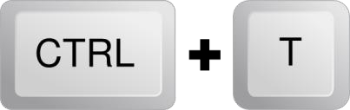

W

Use to open the new tab

Use to close the current tab

a tab is a **clickable** area at the **top of a window** that **shows** another **page** or **area** on **Web browser**.

ACTIVITY  **Activity**



5 MIN

✓Open Web browser

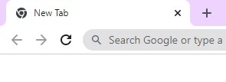

✓**Create** 4 new tabs

✓Search **how navigate** from tab to tab

✓Search **how t**o **restore the closed** pages

# Navigational Buttons

05 MIN

 ✓**Forward/back arrow:** moving backwards and forwards through the order of your visits



 ✓**Refresh:** reloads pages

 ✓**Stop loading:** if you don't want a page to load



# Address Bar

05 MIN

**Address Bar** is somewhere you can **entering** the address of the **webpage** or key words that you want to search on the **Web Browser**.

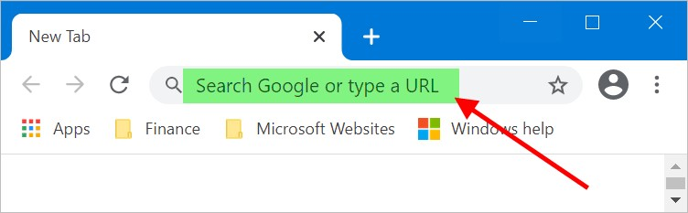

# Bookmark Bar

**Bookmark Bar** is somewhere on the **web browser** where you can easily **access** to your favorite **web pages.**

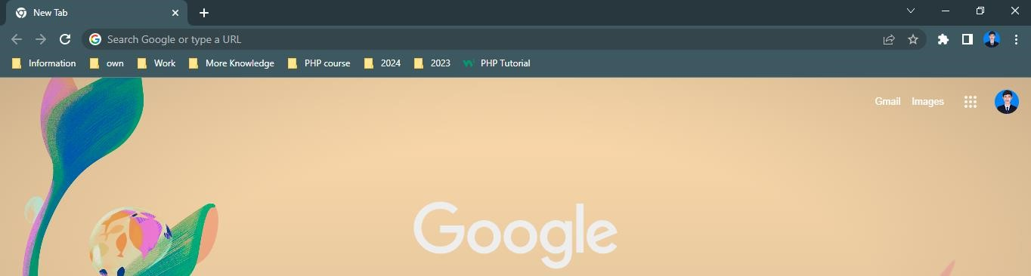

✓ You also can **organize** your favorite **web pages** into the folder on the bookmark bar.

ACTIVITY  **Activity**



5 MIN

✓**Bookmark** three important **websites** :

## ✓PNC timetable ✓Typing website ✓Google classroom

DEMO



10 MIN

# Synchronize Chrome with your Google account

When you sign in to **Chrome** on any **device**, you will get access to your own data

* **Bookmarks**
* **History** and **open tabs**
* **Passwords**
* **Autofill** info and **credit cards**
* **Settings** and **preferences**

EXPLAIN   **Try the Shortcut keys**

05 MIN

|  |
| --- |
| H |

Open new tab View history: 

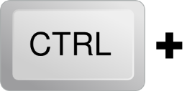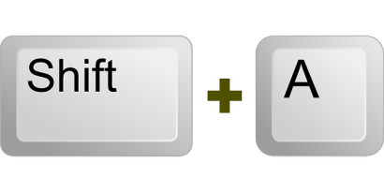

T



W

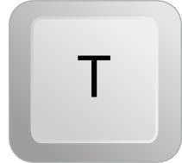

F5



**CTRL**

**Mouse Wheel**



**CTRL**



**Tab**

**-**

**>**

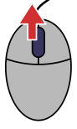

Close tabView Download:

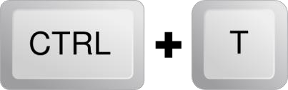

F



J

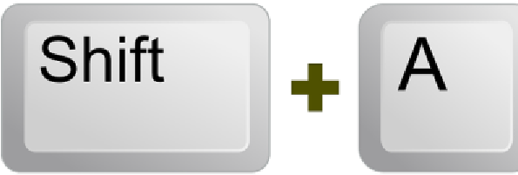

W

Reopen closed tabFind Word:

ReloadClose Browser:

Zoom

Navigate on tabs

ACTIVITY

# Activity



10 MIN

❑Practise using all of the shortcuts with your browser:

✓Open new tab

✓Close tab

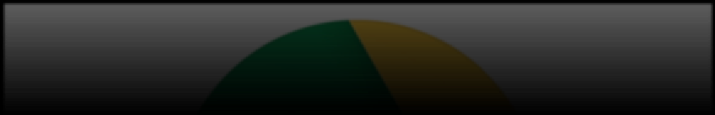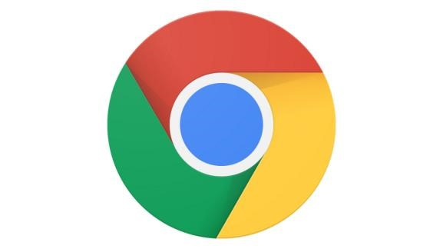

✓Reopen closed tab

✓Reload

✓Display the current website in full-screen mode

✓Back a page

✓Zoom

✓Navigate through tabs

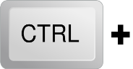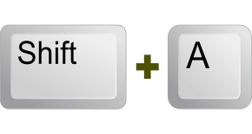

HOMEWORK

Homework

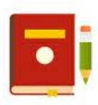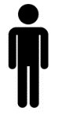

* Review the **slides** send by the teacher

•

**Read**

the handout

•

**Answer**

the questions

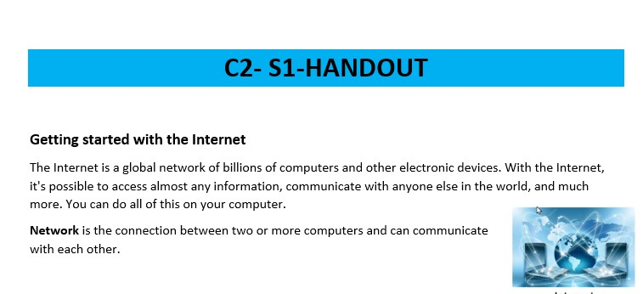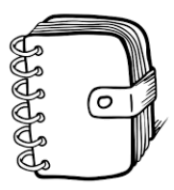

* Review your **draft notes**
* Write **clean notes** on your **BCU workbook**

DRAFT NOTES BCU NOTEBOOK